**CW Machine Window**

# Geoff Anderson G3NPA, Hew Lines VA7HU, Aki Yoshida JA1NLX and Orrin Delany WO4D

## 1.0 GENERAL

### 2.1.2 Keyer Setup - Software

Selecting this menu item will display the Keyer Setup dialog box, as shown below (CWM_6). From this panel the user can:

* + Set the serial port and/or parallel port address to be used;
  + Check which port is going to be active;
  + Select the PTT method;
  + Set the CW speed (faster to the right and slower to the left) in WPM;
  + Adjust the CW weighting;
  + Set the required transmit delay (the time between the PTT being activated and the start of the first symbol to be transmitted);
  + Set the "Disable radio polling when keying" option will do just as it indicates.  This feature was introduced to overcome a problem reported with Omni V rigs when being keyed;
  + Select an immediate character abort when using the <**Esc**> key (rather than allowing the character to complete) when using the software version of the keyer; and,
  + Test the actual keying speed.
  + Check proper pin configulation.

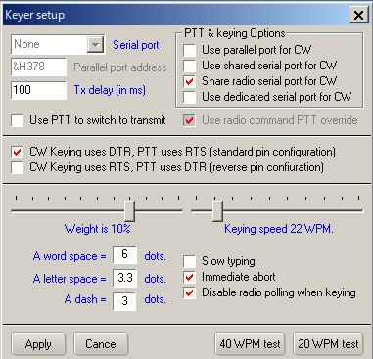

new CWM_6

### 2.1.3 Using the Parallel Port

If you choose to use the parallel port for the CW Machine, all that is required is that you set the parallel port address, select the "PTT on selected port" and "Use parallel port for CW" check boxes.

### 2.1.4 Using the Serial Port

If you choose to use a serial port, you have three options:

* 1. Use a dedicated serial port for PTT control and CW keying;
  2. Key the radio using the spare control signals in the ports used by the rotator or the radio; or
  3. Switch between the radio ports used for SO2R.

**Note**: Only one of these options may be selected at any one tiome.

The serial port selection now supports USB adaptors.

### 2.1.5 Using a Dedicated Port

Select a Serial Port from the pull-down menu and then select "PTT on selected port" if required.

**Note**: Hex address only applies to parallel port selection.

## 6.0 INTERFACING THE CW MACHINE

### 6.1 Software Keyer

You cannot key your radio directly from either the serial or parallel ports from your computer and you will need to construct a simple interface depending on which options you select. A typical interface needed for each control wire is shown below, and this in conjunction with the table of connections should be sufficient to get you operational. This interface assumes that your rig gives a positive voltage onto the control and that this needs to be pulled to zero volts to operate.

**Typical interface circuit**

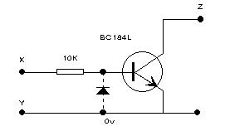

CWM_13

**Notes** on the interface:

* 1. If you are interfacing between a Serial (COM) port and your rig, then include the diode;
  2. If you are interfacing between a Parallel (LPT) port and your rig, then the diode may be omitted;
  3. While a BC184L transistor is specified in the drawing, almost any NPN switching transistor will suffice; and,
  4. The connections to points X, Y and Z in the above diagram should be made in accordance with the following table (standard pin configulation):
  5. You may choose reverse pin configulation option in the Setup table for Software keyer, RTS pin for CW keying and DTR pin for PTT. See CWM_6

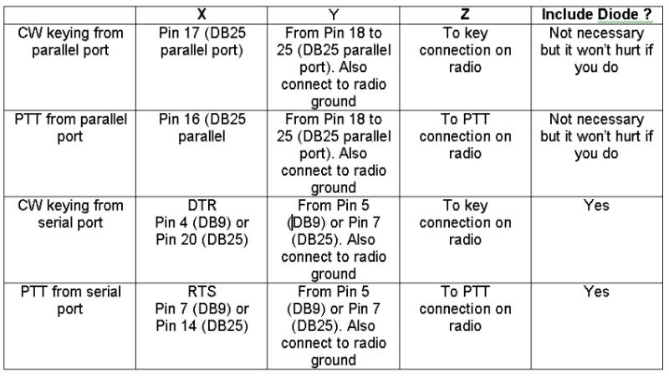

CWM_14

**Note**: If your radio is turned on while Windows is booting up, you may experience a condition where the radio keys up when in the CW mode. To prevent this occurrence, you can use the "STROBE" line (pin#1) as a ground return to the keying circuit. This pin is normally set high when Windows boots up. When you open Logger32 it will set this pin to a low state making it available for CW keying ground return. Additional CW keying information is in the Tips, Tricks and Troubleshooting section.

### 6.2 Alternate Interface

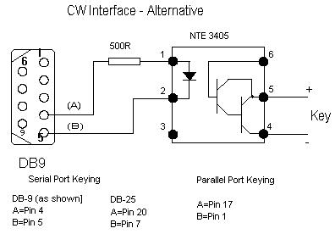

CWM_15

### 6.3 WinKey

Consult your WinKey Interface manual.